GlassDoor Usage Manual
Use the “help” keyword to initiate the bot and display the list of keyword which can be used to view the companies.

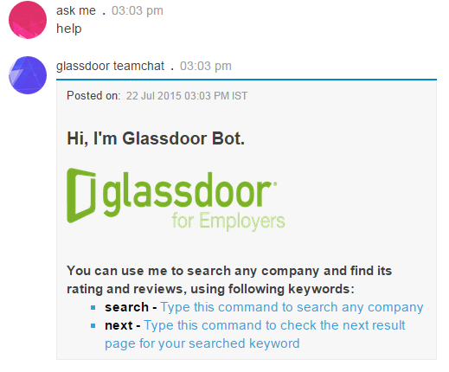

To search companies and details on the basis of location, profession and name use the “search” keyword which gives user the form filling which company details are shown.

To view more companies user can use the “next” keyword which gives user the next company in the same format.

